INTRODUCTION:

My name is Abigail Fisher and this is my twelfth year teaching in Volusia County. I am married and have two adult children. I was born in Deland and I have always lived in this beautiful town.

My philosophy on education is this; all students are capable of learning and growing. My job as an educator is to facilitate learning by creating a safe, positive environment that encourages students to explore learning through guided support, modeling, and discovery.

Welcome to 3rd/ 4th Grade Gifted here at Woodward Elementary, home of the Superstars!

DAILY SCHEDULE

BELL RINGS 7:55

MORNING WORK 8:00

READING 8:15

SPECIAL AREA 10:25

SCIENCE 11:10

LUNCH 12:03

RECESS 12:33

MATH 12:43

SOCIAIL STUDIES 1:30

CLEAN UP/PACK UP 2:00

BELL 2:05

CONTACT INFORMATION

A Fisher

Building 1 Room 14

386-740-7190

[afisher@volusia.k12.fl.us](mailto:afisher@volusia.k12.fl.us)

website: afisherclassroom.weebly.com

**CLASSROOM RULES**

1. Come to class prepared
2. Bring positive attitude
3. Always use kind words
4. Respect the property of others
5. Follow Directions the first time, every time.

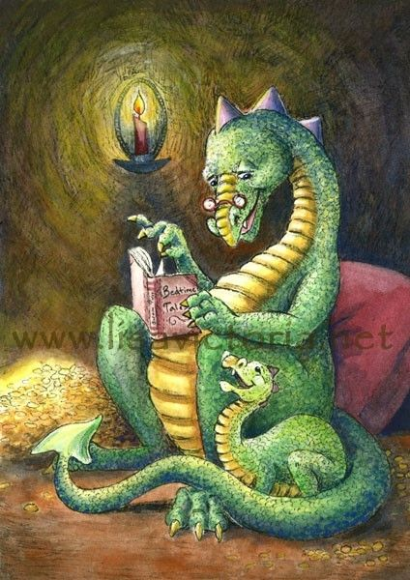

**REWARDS**

We have a house system at Woodward. Your child may earn points for their house by following rules and making good choices.

The four houses are:

Arcturus

Canopus

Sirius

Rigel Kentaurus

These are the names of the four brightest stars in the sky. We believe in our bright Superstars here at Woodward and so we implemented this house system in 2020. If your child has already been sorted into their house, they will continue in that house as long as they remain at Woodward! They will wear their house colors on Tuesdays. If your child has not been sorted into a house, they will be soon.

SPECIAL AREA SCHEDULE

Day 1- Technology

Day 2- PE

Day 3- Art

Day-4- PE

Day-5- Music

Day-6- Media

Please wear sneakers on PE days for safety.



